PYTHON PROJECT

PROJECT TITLE

Drawing an image through rotating vectors , and converting an image into svg format

PROJECT OBJECTIVES

1. USE VARIOUS IMAGE EDGE DETECTION TECHNIQUES
2. CONVERTING AN IMAGE INTO SVG FORMAT AFTER EDGE DETECTION
3. MATHEMATICALA DEMONSTRATION OF FOURIER SERIES
4. GET A GRASP OF PYTHON GUI LIBRARIES
5. LEARN ABOUT LIBRARIES FOR EXAMPLE

MATPLOTLIB, NUMPY , OPENCV , PYQT5

POTYRACE , ETC

INTRODUCTION

CONVERTING AN IMAGE INTO SVG

WE KNOW THE NORMAL IMAGES WE USE IN OUR DAY TO DAY LIFE THAT COMES WITH EXTENSIONS LIKE JPEG , JPG ,PNG THEY ALL ARE BASED ON PIXEL DATA AND ARE MADE UP OF DISCRETE CHUNKS OF PIXELS EACH HAVE THEIR SPECIFIC SET OF VALUES ,WHICH GIVES THEM A FIXED RESOLUTION .

SVG IS A IMAGE FILE FORMAT WHICH STANDS FOR SCALABLE VECTOR GRAPHICS. IT IS USED IN ALL OVER THE PLACES SUCH AS IN TEXT PDFS , APP ICONS , WHILE MAKING ANY GUI . ONE PECULIAR THING ABOUT THIS FORMAT IS THAT THESE IMAGES HAVE INFINITE RESOLUTION .THE EDGES AND GRADIENTS IN THIS IMAGES ARE DEFINED BY MATHEMATICAL FORMULAES , INSTEAD OF SEPARATE PIXEL VALUES . COMPUTER PROGRAMS HANDLING THESE IMAGES BY RESETING THE PIXEL GRID EVERY TIME WE ZOOM IN OUR OUT OF THE IMAGE . COLOUR VALUE OF EACH POINT IN THE IMAGE , IS DETERMINED BY MATHEMATICAL FUNCTIONS , REPRESENTING PATH , STROKE WIDTH , GRADIENT ETC

THESE FUNCTIONS TAKE IN A PRAMETER T AND THE PROGRAM GETS THE IMAGE DATA BY , PUTTING ALL POSSIBLE VALUES OF T (GENERALLY 0 TO 1 ) IN DETERMINED STEPS . ZOOMING IN OR OUT THE PROGRAM JUST RECALCULATES THE STEP SIZE AND RECALCULATE IMAGE DATA

THE MOST KNOWN MATHEMATICAL EQUATIONS USED IN THIS IMAGES TO SPECIFY PATH OF A LINE ARE

1. BEZIER CURVES (CUBIC ,QUADRATIC)
2. LINEAR INTERPOLATION
3. HERMITE SPLINE
4. NERB ETC

BASICALLY ALL THIS ARE SOME KIND OF SPLINES AND CAN BE CONVERTED INTO ONE ANOTHER BY CHANING DIFFERENT PARAMETERS

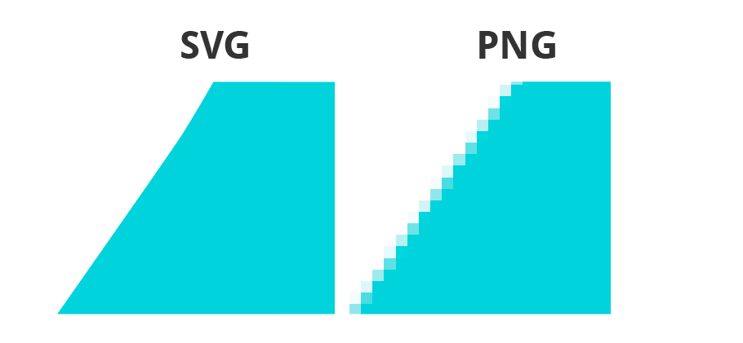

CONVERTING IMAGE INTO SVG

PROGRAM USED

THE PROGRAM THAT I HAVE MADE APLLIES AN DIFFERENT EDGE DETECTION ALGORITHMS ON THE GIVEN IMAGE AND GET ITS CONTOUR DATA . AFTER IMAGE EDGE DETECTION THE PROGRAM CONVERTS THE EDGE_DETECTED IMAGE INTO A BIT MAP (HAVIHNG PIXEL VALUES ONLY 0 OR 255), WHICH IS TAKEN IN BY A PYTHON MODULE KNOWN AS POTRACE WHICH CALCULATES THE CURVE DATA FOR ALL THE DIFFERENT EDGES IN THE IMAGE , BY GETTING THE CURVE DATA WE CAN MAKE A SVG IMAGE , OR ELSE USE THAT DATA TO USE IN SOME OTHER COMPUTER VISION OR IMAGE MANUPULATION TECHNIQUES

ANOTHER MODULE THAT I HAVE USED IS SvgPathtools WHICH PARSES A SVG FILE AND GETS THE PATH DATA . ALSO IT HAS A FUNCTION THAT TAKES A T PARAMETER BETWEEN 0 AND 1 AND GIVES THE PATH CORDINATE FOR THAT GIVEN VALUE OF T , PASSING A LIST OF EVENLY SPACED T VALUES TO THE FUNCTION WE CAN TRACE ALL THE PATHS IN THE IMAGE AND MAKE A PLOT OF EDGES IN THE IMAGE

DRAWBACKS OF THIS METHOD

1. MY PROGRAM LOSSES THE COLOUR DATA OF THE IMAGE AND CONVERTS IT INTO A STRICT VECTOR BITMAP . THOUGH IT IS POSSIBLE TO MAKE COLOURED SVGs BUT IT IS OUT OF SCOPE FOR THIS PROGRAM TO CONVERT A REGULAR IMAGE INTO A COLOURED SVG AND IT HAVE MUCH MORE COMPLEXITITES THAT A NORMAL BITMAP

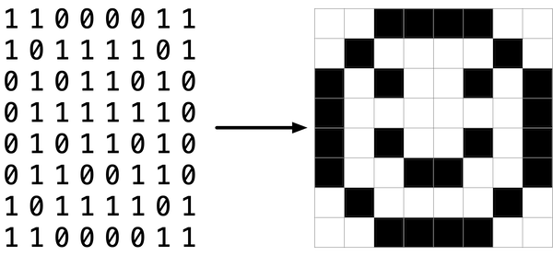

DRAWING AN IMAGE THOUGH ROTATING VECTORS

THIS PROGRAM IS JUST A CREATIVE DEMONSTRATION OF APPLICATIONS OF FOURIER SERIES BASICALLY WHAT I AM DOING IS PARSING A SVG IMAGE , THUS OBTAINING ITS PATH DATA THROUGH OUR OLD FRIEND POTRACE LIBRARY

OR I CAN ALSO USE A CUSTOM SVG PATH , ALL I NEED IS A COPLEX VALUES FUNCTION THAT TAKES IN A PARAMETER T AND GIVES A COMPLEX OUTPUT WHICH IS THE POINT DATA FOR THAT VALUE OF T

WE CAN ASSUME THIS A COMPLEX VALUES FUNCTION WHICH MEANS IT WILL HAVE A FOURIER SERIES

WE CAN REPRESENT THAT FUNCTION AS

$$\text{Z(t)=}\sum_{-P}^{P}{C_{n} .exp⁡(i.2.π.n.t)}$$

IT IS THE COMPLEX FOURIER SERIES WHERE Cn CAN BE CONSIDERED AS A 2D VECTOR WITH SOME INITIAL AMPLITUDE AND PHASE WHILE THE EXPONENTIAL TERM IS A TRANSFORMATION THAT ROTATES THAT VECTOR WITH SOME INTEGER FREQUENCY N WITH PARAMETER T FROM 0 TO 1

GETTING THIS COEFFICIENT Cn THE KEY TO OBTAIN A TRACE , WE GET MORE AND MORE FREQUENCIES WE USE AND SMALLER THE TIME STEP WE USE FOR INTEGRAION IN ORDER TO FIND Cn

FINDING Cn IS EXTREMLY EASY IT IS JUST

$$C_{n}=\int_{0}^{1}{Z\left(t\right).\exp\left(-i.2.π.n.t\right).dt}$$

WE WILL CALCULATE THIS INTEGRAL BY USING RIEMANN SUM I.E BY GETTING THE CURVE VALUE FOR DIFFERENT T AND ADDING THE PRODUCT OF CURVE VALUE AND T STEP IN THE GIVEN RANGE , DECREASING THE T STEP GIVES US THE MORE ACCURATE VALUES OF Cn

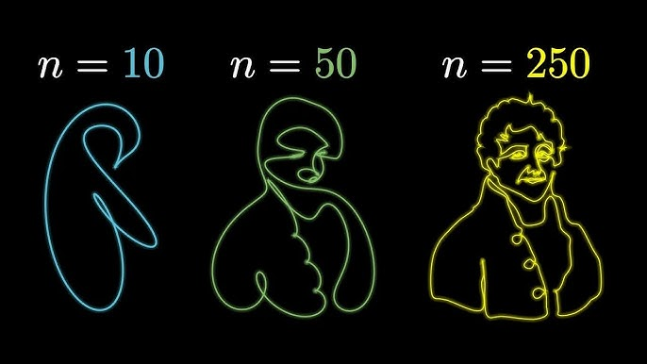MILESTONES

1.LEARNED NUMPY

2. LEARNED MATPLOTLIB

3.GUI DEVELOPMENT WITH PY QT

4.SUCCESFULL EDGE DETECTION WITH PY POTRACE

5. CLASSES IMPLEMENTATION

6. FILE MANUPULATION

7.LEARNED OPEN CV

MILESTONES FAILED TO ACHIEVE

1. COMPLETING UI AND FIXING ALL THE BUGS
2. MAKING UI INSTALLER
3. GETTING SVG COLOUR CONVERSION
4. STICKING TO MATPLOTLIB FOR PLOTTING GRAPH INSTEAD OF FATSER AND VISUALLY BETTER LIBRARIES LIKE OPENGL

RESOURCES USED

1. PYQT5 : IT IS A EXTENSIVE GUI LIBRARY WITH VARIOUS WIDGETS AND BINDING WITH OTHER POPULAR LIBRAIRES FOR GUI DEVELOPMENT
2. PYQT5 DESIGNER : IT IS A SOFTWARE THAT IS AVAILABLE IN PYQT5 TOOLS LIBRARY AND GIVES A VISUAL WAY TO DESIGN A WEBSITE

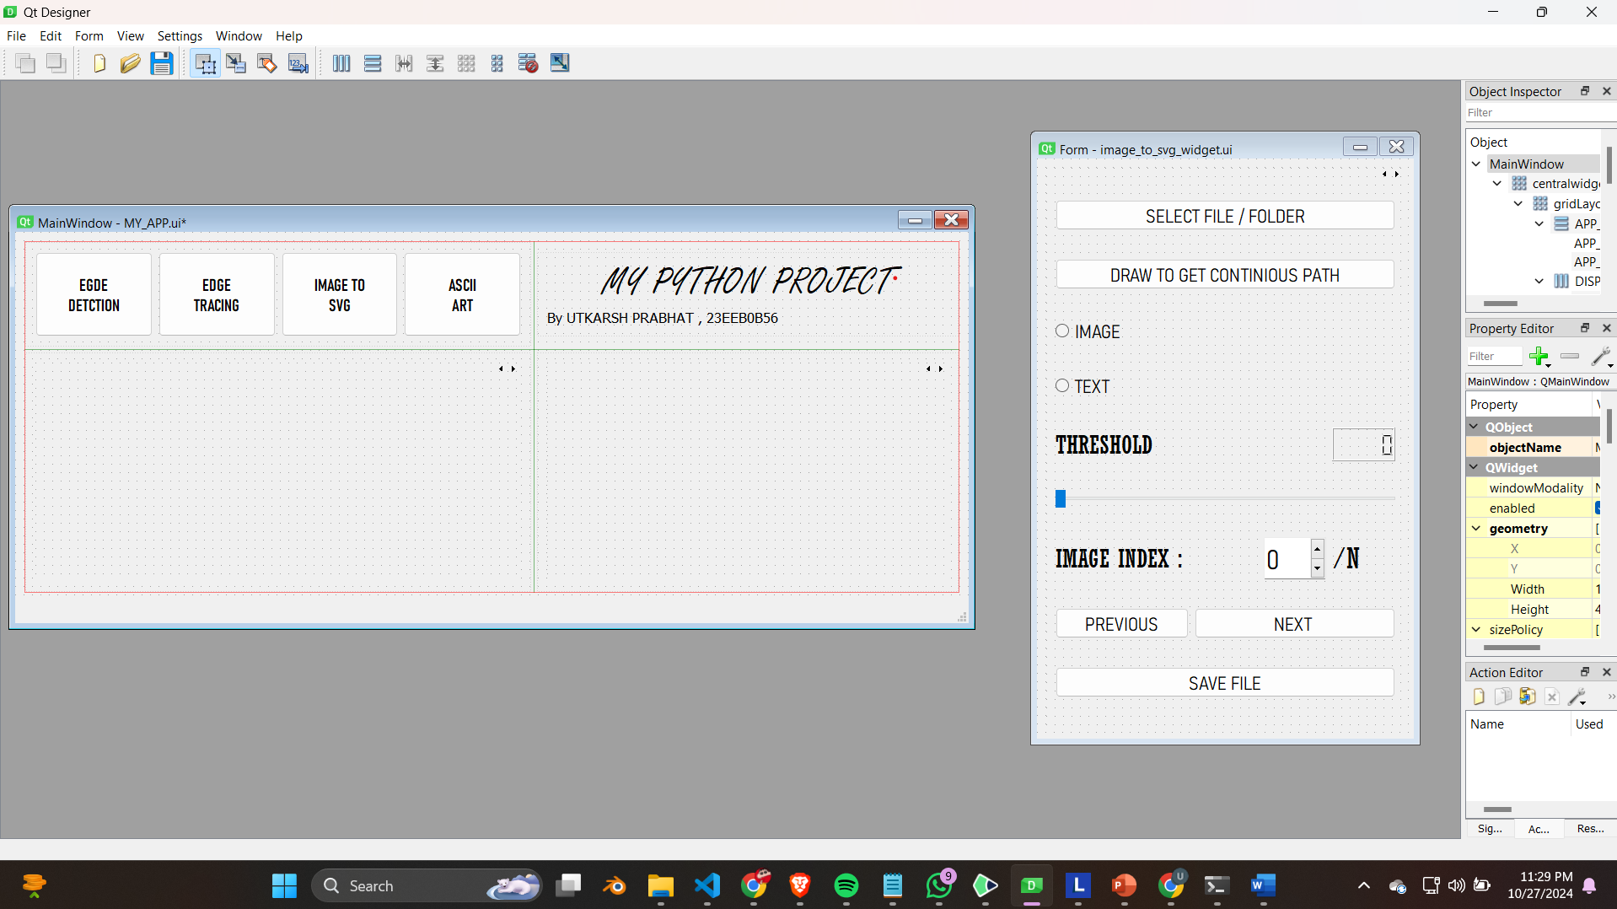

NORMAL IMAGE



CANNY EDGE DETECTION

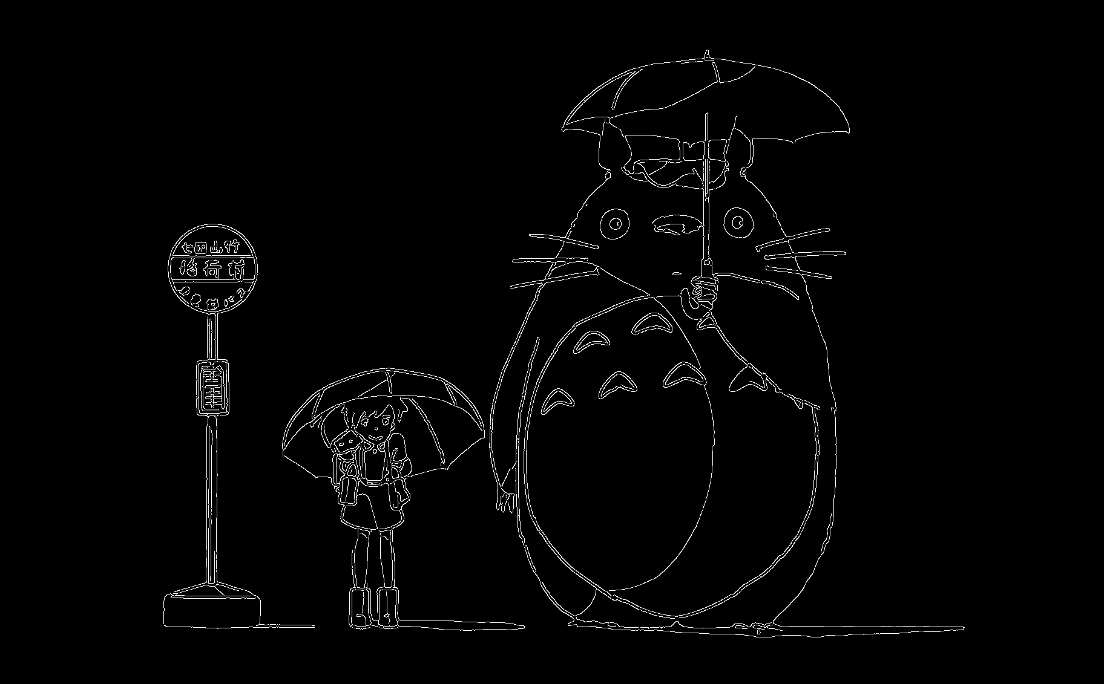

BITMAP



FILE SYSTEM



1. MAINAPP.FILE CONTAINS .EXE FILES FOR DIRECU RUNNING
2. PROJECT DOC HAVE REPORT
3. PYTHON FILES HAVE MAIN PYTHON FILES WHICH HAVE ALL THE CODE THOUGH IT IS JUST FOR REVIEW IN THIS FOLDER
4. PYTHON TEST FILES ARE THE TEST FILES THAT I MADE ALONG THE PROCESS TO TEST VARIOUS LIBRARIES AND FUNCTION
5. SAMPLE IMAGES CONTAIN SOME IMAGES TO WORK WITH THE APPS
6. UI FILES CONTAIN .UI FILES TO EDIT WITH QT DESIGNER